To | Dept./Address
Robotarm users

Copy | Dept./Address

From | Dept./Address
Rob Beekmans |  | Tel.: +31 40 2748502  E-mail:  r.a.beekmans@philips.com
 | Ref: - | Date: 2010-04-14

Subject: Robotarm Network settings

To change the network settings of the robotarm system, the following steps have to be taken:

1 – open the Network connections settings control, see the figure below where this control can be opened.

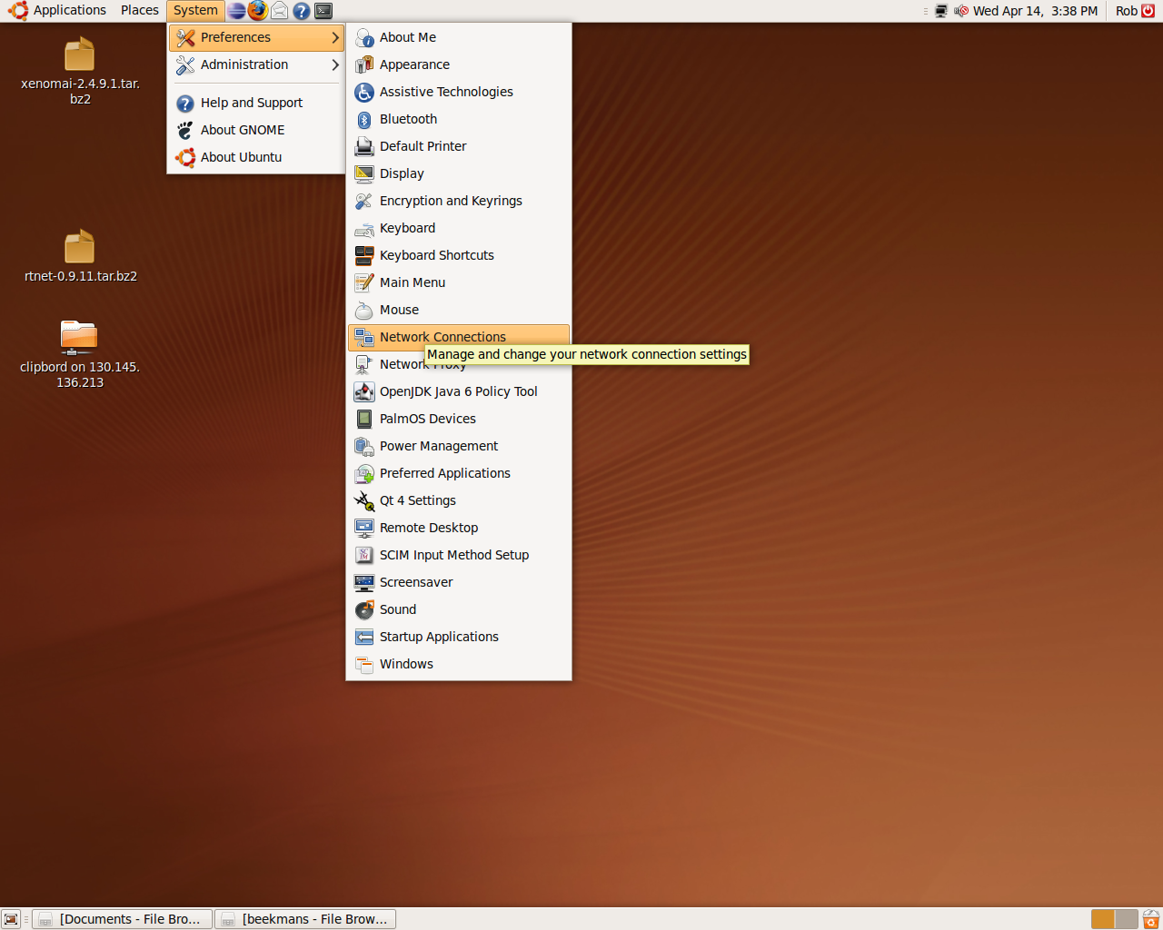
Figure 1: Open Network Connections control

2 – In the Network Connections control select the Auto Eth0 connection and click on the Edit button on the right side to configure the connection. After clicking on Edit a dialogue that prompts for the administrator password is displayed, enter the password ( test ).

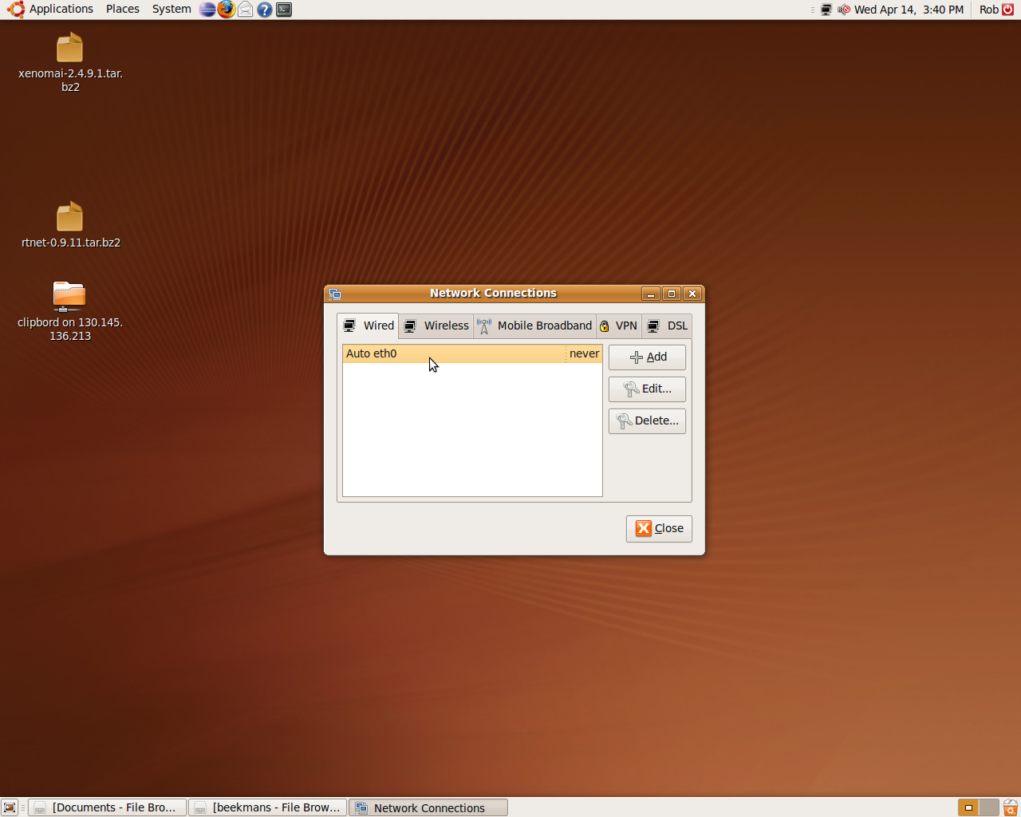
Figure 2: Network Connections control

3 – In the Auto Eth0 connection dialogue, select the Ipv4 Settings tab.

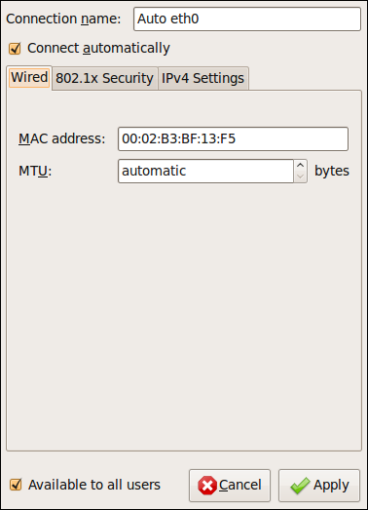
Figure 3: Auto Eth0 connection dialogue as shown first

4 – the dialogue displayed below is the default, the connection method is DHCP

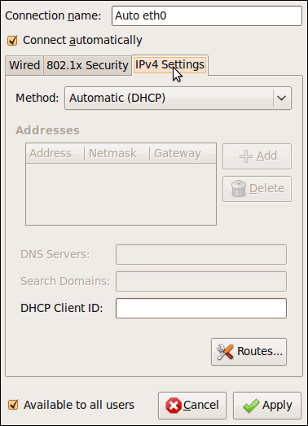
Figure 4: Auto Eth0 connection dialogue with default settings for IPv4

5 – To enter a fixed IP – address, select connection method Manual and fill in the address and netmask fields.
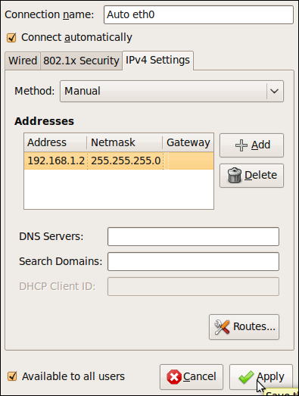
Figure 5: Auto Eth0 dialogue with fixed IP-address settings

6 – when finished, click on Apply, this will return to the Network connections control.

7 – In the Network connection control, click on Close.

8 - Wait a short time for network settings to become active.

